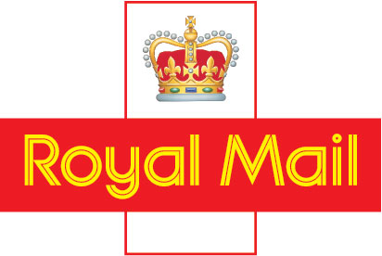

News Release
21st September 2007

Strictly embargoed until 07.00

ROYAL MAIL ANNOUNCES REVISED THAMES VALLEY AND GLOUCESTER NETWORK PLAN

Royal Mail has announced a revised plan for the £20m transformation of the Thames Valley and Gloucester postal network to maximise customer quality of service in the region.

The original plan, announced in September 2006, has been revised to address an urgent need to improve mail consistency and efficiency in the OX postcode area. The changes will address once and for all the problem of inconsistent performance and quality of service delivered to our customers in the region.

As a result:

- Oxford and Reading Mail Centres will close in 2009 and work will transfer to Swindon

- Gloucester Mail Centre will not now move to Swindon as originally planned

Delivery and collection operations across the Swindon, Oxford, Reading and Gloucester postcode areas will not be affected.

The new plan is central to Royal Mail's need to modernise its postal operation and to allow it to compete on quality of service and price in the now fully competitive postal market.

MORE

"We believe that moving work from Oxford to our extended facility in Swindon, which will be equipped with the latest technologies, will enable us to address an urgent need to improve the reliability of the mail services for our customers in the OX postcode area," explained Michael Devanny, the Area General Manager.

"Our first priority as we take forward this plan will be to fully support staff at all sites, particularly recognising the impact on our Oxford colleagues as a result of the revisions to our original proposals.

He said, “Royal Mail would put into place a very positive support package to help its people through any period of change. Royal Mail has an excellent track record of managing people through change and we will consult with the unions and our employees in the coming weeks and months to help them through this difficult time.”

The timescale for development of the extended Swindon Mail Centre will mean a full transfer of work from Oxford and Reading Mail Centres by early 2009.

Development work is due to start at Swindon on 8 October and once complete, the mail centre will be the largest, most state of the art in the country.

As part of the plans Royal Mail will develop a new delivery office for central Reading.

ENDS

For further information please contact Group Communications on 0121 212 3068.

Notes to Editors

- Royal Mail's original plans to transform the Thames Valley and Gloucester network involved the relocation of Gloucester and Reading Mail Centre operations to an extended Swindon Mail centre site.
- Royal Mail Thames Valley and Gloucester incorporates the GL, OX, SN and RG postcode areas. The mail centres for each area are at:

Reading Mail Centre, 80 Caversham Road, READING, RG1 1AA
Gloucester Mail Centre, Eastern Avenue, GLOUCESTER, GL4 3AA
Oxford Mail Centre, Alec Issigonis Way, Oxford Business Park North, OXFORD OX4 2ZZ
Swindon Mail Centre, Royal Mail House, Rowland Hill Close, Swindon, SN3 5TQ.

